**Project Development Phase**

**Model Performance Test**

|  |  |
| --- | --- |
| **Date** | **21st November 2022** |
| **Team ID** | **Team - 591979** |
| **Project Name** | **ASL - Alphabet Image Recognition** |
| **Maximum Marks** | **10 Marks** |
| **Team members** | **Pujyam Sathvika, Rishika Krishna Ch** |

**Model Performance Testing:**

|  |  |  |  |
| --- | --- | --- | --- |
| **S.No.** | **Parameter** | **Values** | **Screenshot** |
|  | Model Summary | Total params: 9404509  Trainable params: 2367005  Non-trainable params: 7037504 |  |
|  | Accuracy | Final training accuracy – 0.9581 |  |

**Screenshots:**

Model Summary:

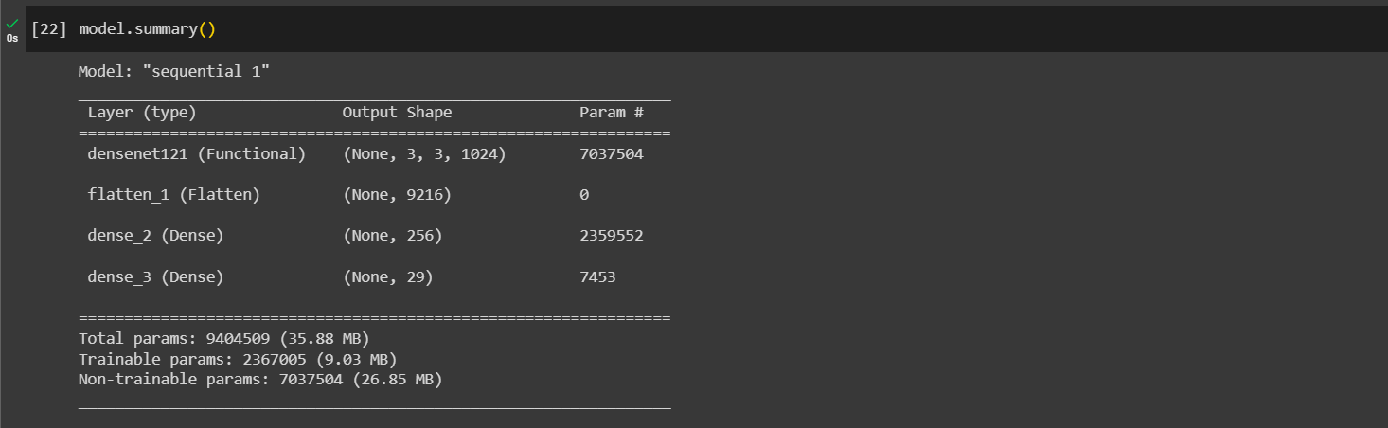

Training accuracy:

